**Name/** Mohamed Mahmoud Ahmed Mahmoud Eldeeb

**B.N/**792

**Code**/ECE001

**E-Mail**/ [muhammed195884@feng.bu.edu.eg](mailto:muhammed195884@feng.bu.edu.eg)

Github link: https://mohamed-el-deeb.github.io/ECE001/

# Artificial Intelligenc

## Brief Section:

The idea of inanimate objects coming to life as intelligent beings has been around for a long time. The ancient Greeks had myths about robots, and Chinese and Egyptian engineers built automatons.

The beginnings of modern AI can be traced to classical philosophers' attempts to describe human thinking as a symbolic system. But the field of AI wasn't formally founded until 1956, at a conference at Dartmouth College, in Hanover, New Hampshire, where the term "[artificial intelligence](https://www.livescience.com/3407-robot-madness-creating-true-artificial-intelligence.html)" was coined.

MIT cognitive scientist Marvin Minsky and others who attended the conference were extremely optimistic about AI's future. "Within a generation [...] the problem of creating 'artificial intelligence' will substantially be solved," Minsky is quoted as saying in the book "AI: The Tumultuous Search for Artificial Intelligence" (Basic Books, 1994). [[Super-Intelligent Machines: 7 Robotic Futures]](https://www.livescience.com/29376-rise-of-super-intelligent-robots.html)

But achieving an artificially intelligent being wasn't so simple. After several reports criticizing progress in AI, government funding and interest in the field dropped off – a period from 1974–80 that became known as the "AI winter." The field later revived in the 1980s when the British government started funding it again in part to compete with efforts by the Japanese.

## Screen shoot section

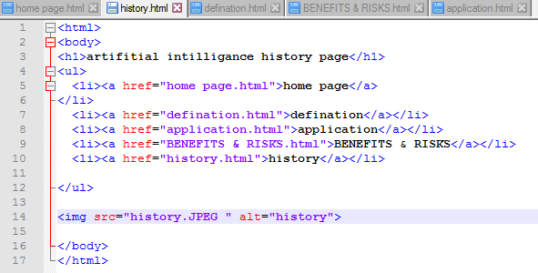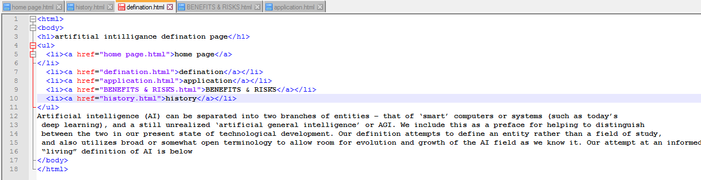

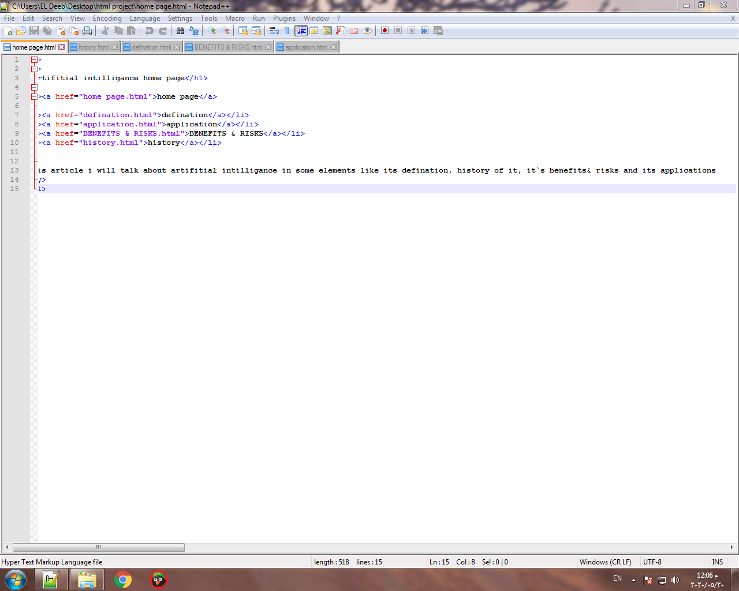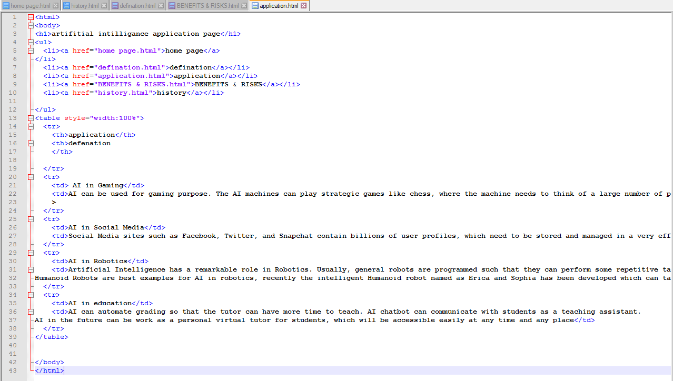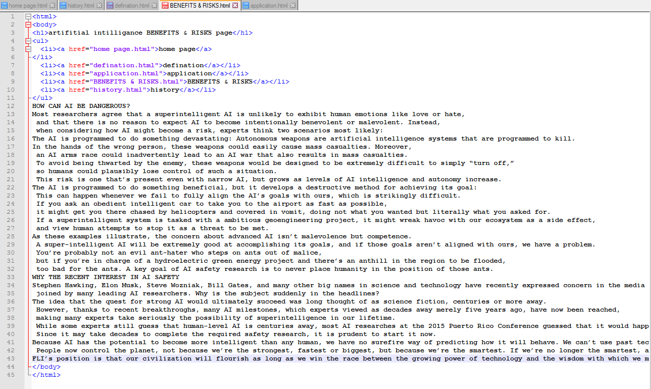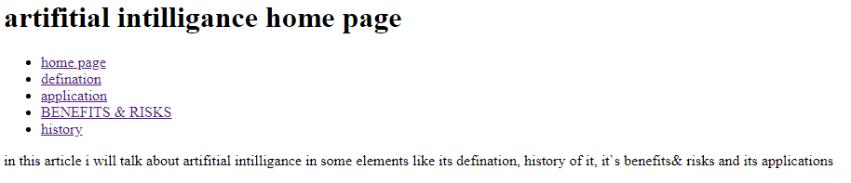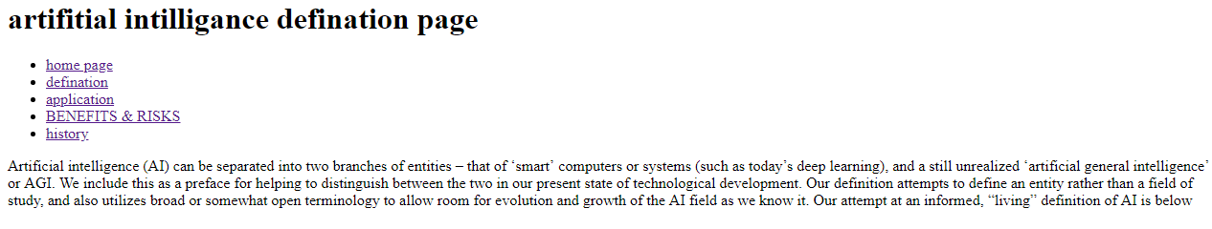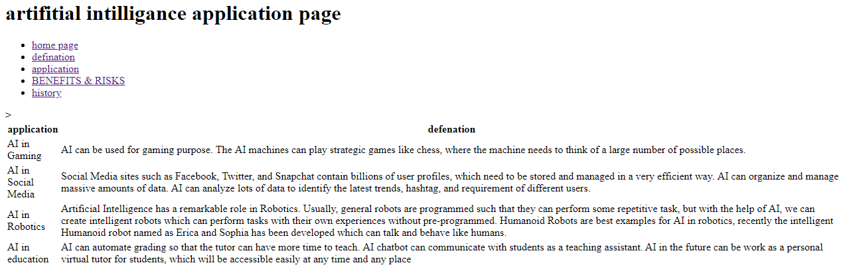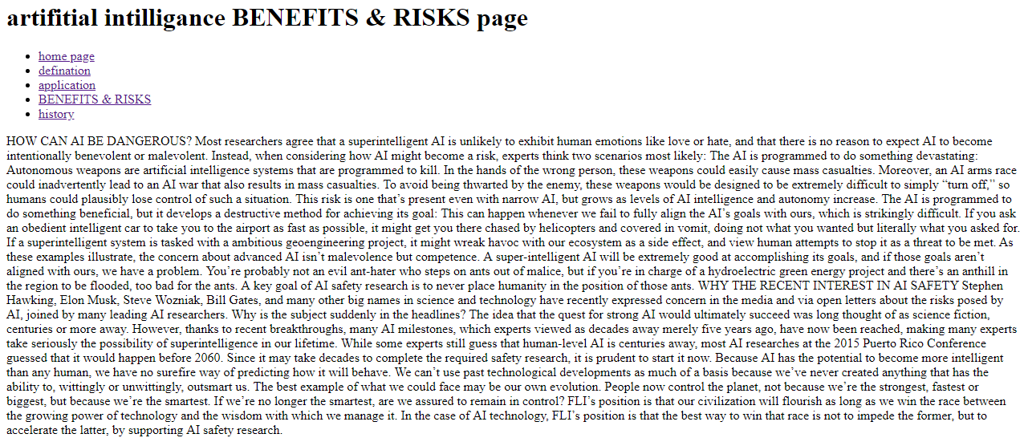

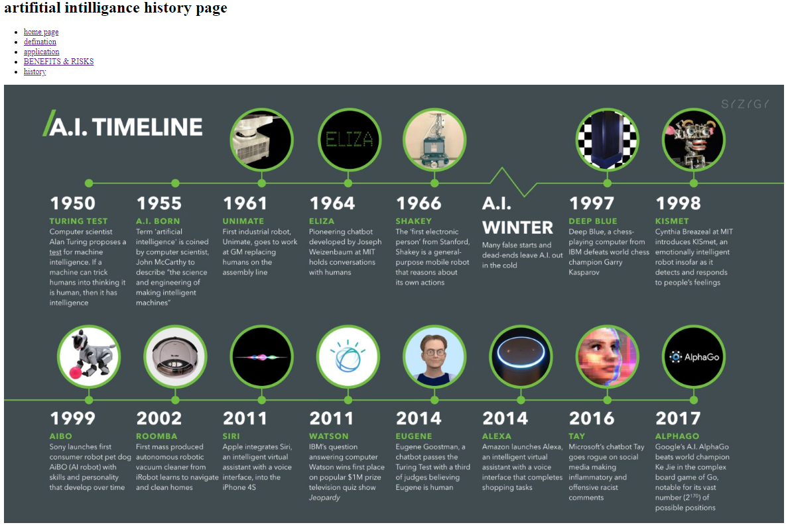

References

1/<https://searchenterpriseai.techtarget.com/definition/AI-Artificial-Intelligence>

2/<https://www.javatpoint.com/application-of-ai#:~:text=Artificial%20Intelligence%20has%20various%20applications,life%20more%20comfortable%20and%20fast.>

3/<https://futureoflife.org/background/benefits-risks-of-artificial-intelligence/>